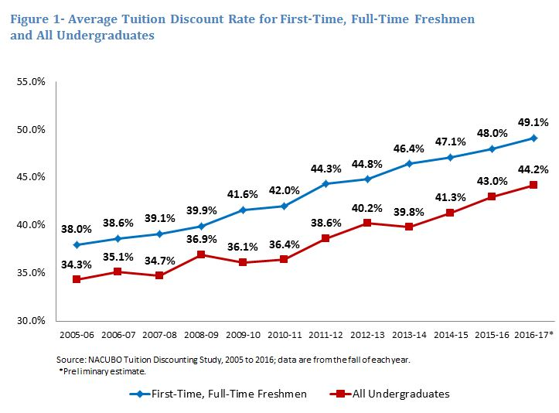

Financial Stability
In Topic two, we identified a university that had failed. This was due largely to the debt the university was unable to repay. This institution was not financially stable. This problem did not occur overnight, but over an extended period of time. Being financially stable is vital for a university. Let’s revisit the performance indicators discussed in lesson one. Of the 66 indicators, at least 34 of them (> 50 percent) have financial implications. Use of these “financial” key indicators to make decisions is one way to ensure financial stability.
Some of the financial KPIs that are also listed among Fragility Indicators are endowment, operating budget, enrollment, alumni giving, retention, tuition discounting, tuition dependency, and debt service. Here are two examples of analyzing these:
- Fragility Indicator: The ratio between endowment and operating budget is less than 1-to-3. So if the operating budget is $70M, then the endowment should be 3 times that much--$210M.
An endowment is any asset donated to and for the perpetual benefit of a non-profit institution. The donation is usually made with the requirement that the principal remain intact and money earned from investing the principal be used for a specific purpose.
- Fragility Indicator: Tuition discounting is more than 35 percent. Tuition discounting is another name for student scholarships. When college students receive scholarships, many times the institution is foregoing that cash. So if tuition is $20,000 for one year, and the student receives a $10,000 scholarship, the college is receiving only $10K in cash for its operations.
Please view the graphic representation of discount rate increases on our class site, which was taken from a May 2017 article entitled Discounting Keeps Climbing found in Inside HED.

Also in Lesson two, we discussed the standards of regional accreditors. Please visit this website again http://www.sacscoc.org/pdf/2018PrinciplesOfAcreditation.pdf. Read Section 13 (page 29)of the Principles of Accreditation: Foundations for Quality Enhancement. A PDF of the document is among the resources in this topic or you can use the link found above.
Delving into these, you find the subtitles located in parentheses: financial resources, financial documents, financial responsibility, control of finances, control of sponsored research/external funds, federal and state responsibilities, physical resources, and institutional environment. All of these are important for college administrators to understand.
Several standards speak to the financial control the university should have. One of the ways an institution provides information concerning financial controls is the annual external audit. The external auditor publishes an opinion concerning the viability of the institution and makes recommendations to the university management. A management letter is a formal, written document that conveys the auditor’s findings and observations about particular aspects of the university’s business. These letters generally inform the university leadership of the procedures the auditor performed while doing the audit and what the auditors determined. Most importantly, the letter identifies financial strengths and weaknesses of the university. Recommendations are given and expected to be implemented before the next annual audit.
With the recent financial debacles in industries such as Enron, WorldCom, and others, new legislation was passed. Currently this legislation only applies to public companies, but the trend is to apply new rules to private companies and institutions. Read more about the Sarbanes-Oxley Act at this website: http://en.wikipedia.org/wiki/Sarbanes-Oxley_Act. This act also cause companies and colleges alike to create a Whistleblower Policy. Please read this policy found among this Topic's resources.

Affordable Christian Colleges: MC ranks #22
Click https://www.greatvaluecolleges.net/affordable/accredited-online-christian-college-universities/ link to open resource.

Changes in Revenue Streams
Reduction in state funding: Many universities face fluctuations in their revenue streams that can cause financial insecurities. One such fluctuation might be a reduction in state funding. Please read the article “Financing Higher Education: A Crisis in State Funding” found at the National Education Association’s Higher Education website (link is on the front page).
Enrollment decreases: In other institutions that are tuition-driven, an enrollment decrease can adversely affect the revenue of the institution. Enrollment is an important indicator for all universities, but especially those that have limited resources. Note that one of the fragility indicators is enrollment of less than 1,000 students.
Affordability: Today’s college student expects to get value as a result of a college education. In the article “Is Demography Destiny?” found on pages 29-30 of the January 2007 University Business magazine, Robert A. Sevier notes that being known for something students value will result in students’ willingness to pay more for tuition. Many factors should be considered when deciding on tuition price. One of those factors is affordability. Some questions to be asked are as follows:
- What is the average annual family income for the market the university serves?
- Have tuition increases been dramatic? One of the Dashboard Fragility Indicators is average tuition increases exceeding 7 percent.
You may remember that several of the Dashboard Fragility Indicators deal with these same issues:
- Institutional enrollment below 1,000,
- Tuition dependency of more than 85 percent, and
- Average tuition increases exceeding 8 percent for 5 years.
Several strategies exist to overcome the change in revenue streams:
- Go after new markets. In 2003, Mississippi College decided to go after the international student market. This graph represents what the institution looked like in 2003 in regards to international student. The university’s strategic plan added objectives dealing with this market. Resources were allocated. As a result of the successful implementation of this plan, Mississippi College enrolled over 400 international students. Unfortunately, the international student market has declined in recent years. That is the value in having a diverse population of students.
- Begin new academic programs. Universities can add degree programs, reshape existing degree programs to meet community needs, offer degree programs at additional locations, add on-line programs, and add degree programs for adults and other special groups. I will use Mississippi College as a case study.
Mississippi College has added at least one new graduate degree since 1999. In most years, two graduate programs have been added. The following table shows graduate headcount in recent years:
Fall 2013 | Fall 2014 | Fall 2015 | Fall 2016
1,536 | 1,560 | 1,631 | 1,532
*Source KPI#19
In 2003, MC's graduate headcount was 612. So the steady enrollment of 1,500 plus graduate students represents a significant increase in graduate enrollment, which is a valuable resource for the institution. This increase provides a total enrollment of over 5,000 students for Mississippi College. As you may recall, this was a strategic decision providing action on objectives given in Topic two.
- Revamp existing academic programs. In some cases, academic programs need updating to make the offerings match the needs of the workforce. This may make the programs more attractive to students.
- Market your programs. No matter how good your academic programs are, they must be marketed. In Topic six, we will discuss marketing.
- Use continuing education. Continuing education can be a lucrative enterprise used to generate revenue based on non-traditional offerings.
- Utilize resources for other events. Facilities can be leased for other purposes when the usage for regular academic programming is down. For example, Mississippi College allows its physical facilities to be used for youth camps during the Summer months.
- Outsource auxiliary services. Rather than creating a revenue stream, this strategy focuses on reducing the loss that may be incurred through some auxiliary services. Many universities outsource their food services. More and more universities are outsourcing their bookstore. This allows the university to focus on what it does best—educate, while allowing others to do what they specialize in, such as providing food or books.
- Look at other fund raising strategies i.e. grants.
- Analyze efficiencies of academic programs. Again this provides more information on how to reduce costs rather than increase revenue; however, it has the same net affect. Every two years, Mississippi College reviews a report entitled “Efficiency Analysis.” It contains the following information organized by department:
  - Total undergraduate classes,
  - Total undergraduate hours,
  - Total graduate classes,
  - Total graduate hours,
  - Total # of seats,
  - Undergraduate discount%, and
  - Net revenue per hour.
The purpose of this efficiency analysis is help units see where efficiencies can be enhanced. In essence, this is an academic audit.

Changing HED Business Model
Click https://www.forbes.com/sites/lucielapovsky/2018/02/06/the-changing-business-model-for-colleges-and-universities/#6860e8ac5ed5 link to open resource.

Budgets
Universities must create budgets; the key is providing a good budgeting process with appropriate input that allows for insightful use of resources based on the university’s priorities. According to Western Washington University’s budget website, “central elements of these functions include the preparation and submission of the institution's biennial operating budget request, annual allocation plans, and ensuring that financial resource decisions are in concert with the institution's clearly defined strategic planning objectives.” Western Washington University’s website for budgeting can be found at https://budgetoffice.wwu.edu/
The typical steps in the university budgeting process are as follows:
- The budget officer creates a budget based on input from its users.
- The budget is approved by
  - The President,
  - The Finance & Audit Committee (a board committee), and
  - The full Board of Trustees.
Please study the powerpoint presentation entitled "Things your CFO wants you to know."
By monitoring the university budget, management can watch for the Dashboard Fragility Indicator “successive operating budget deficits.”
Organizational culture can be a contributing factor to a particular university’s budgeting process. According to Dr. Carter McNamara of Authenticity Consulting, “culture is comprised of the assumptions, values, norms and tangible signs (artifacts) of organization members and their behaviors.” Each organization has its own unique culture. Therefore, managers must be cognizant of the university culture. For the article by Dr. McNamara, see this https://managementhelp.org/organizations/culture.htm
WACUBO provided a Powerpoint that overviews higher education budgeting for you to view:
https://www.buffalo.edu/content/dam/www/provost/files/FacultyAffairs/WACUBO_HigherEducationBudgeting.pdf

